Ref – Atreya A, Acharya J, Kanchan T. Face off and alcohol consumption – A case series. Anil Aggrawal's Internet Journal of Forensic Medicine and Toxicology [serial online], 2015; Vol. 16, No. 1 (Jan - June 2015): [about 9 p]. Available from: http://anilaggrawal.com/ij/vol_016_no_001/papers/paper007.html. Published as Epub Ahead : Nov 3, 2014.

Access the journal at - http://anilaggrawal.com
*************************************************************************

Case Report

Face off and alcohol consumption – A case series

Authors (with affiliation)
Alok Atreya, MD (Lecturer), Department of Forensic Medicine, Manipal Teaching Hospital, Pokhara, Nepal.
Jenash Acharya, MD (Lecturer), Department of Forensic Medicine, Kathmandu Medical College Teaching Hospital, Kathmandu, Nepal.
Tanuj Kanchan, MD (Associate Professor), Department of Forensic Medicine, Kasturba Medical College, Mangalore (A constituent College of Manipal University), India.

Corresponding Address

Dr. Tanuj Kanchan, MD
Associate Professor, Department of Forensic Medicine, Kasturba Medical College, Mangalore (A constituent College of Manipal University), India.

E-mail: tanujkanchan@yahoo.co.in; tanuj.kanchan@manipal.edu

Phone: +91-9448252394 (Mobile)

No support in form of grants

No conflict of interest to declare

Title: Face off and alcohol consumption – A case series

Abstract
During sudden altercations, the more easily available and accessible weapons are frequently used to assault; head and face being the vulnerable parts in such fatal attacks. These incidents are mostly unplanned, and occur in a fit of rage, alcohol often being a contributory factor. The present case series highlights the unique facial injuries caused following arguments during alcohol consumption, and using easily accessible weapons in the surrounding. Gorkha Khukuri knife used as a weapon of offence in the first case is a utility knife used by Nepalese population. Fish hook used as a weapon of offence in the second case in fact is a very uncommonly used weapon in cases of assaults.

Keywords

Assault; Alcohol; Crimes; Facial injuries

Introduction
WHO estimated that alcohol contributes approximately 9% of the burden of disease and disability in developed countries, making it the third-highest risk factor for morbidity. Alcohol-related harm is a widespread problem. Two billion people worldwide are estimated to consume alcohol; 76 million of those have a diagnosable alcohol use disorder [1]. Alcohol, although considered a bottled poetry by many can at times be a risk factor for either being victimized or perpetrating a crime. As per the World Health Organization (WHO) estimates, approximately four and a half percent of the global burden of disease and injury is attributable to alcohol. Alcohol consumption is estimated to cause from 20% to 50% of cirrhosis of the liver, epilepsy, poisonings, road traffic accidents, inter personal violence, sexual violence and several types of cancer [2]. At times when excess amount of alcohol meets young blood, matters may even get worst and the degree of violence is usually devastating. Besides the well-known effect of alcohol on cognitive and physical functions like disinhibition, where the normally suppressed behavior are expressed, alcohol also has an equal role in reducing self-control and increasing emotional liability and impulsivity [3,4].
We report a series of cases from Nepal where the victims were assaulted by their near-ones following altercations during alcohol consumption.

Case 1
A 21 years old male was brought to the emergency, who had stable vitals and Glasgow Coma Scale computed 15/15, with a complaint of multiple sharp force injuries over head and face. Alleged history suggested that he met with an argument with his fellow drinker, known to be his friend, who on sudden altercation impulsively rushed to his house nearby and hastily came back with a heavy sharp cutting weapon, allegedly a “Gorkha Khukuri Knife” and pounded on him. The weapon was glazed into the right temporal region resulting in de-gloving of the right lateral part of the face and neck slicing the pinna of right ear into two halves and exposing the underlying dura. The total length of the wound measured 22 cms (Figure 1). The direction of the blow was above downwards and lateral to medial which sliced the skin and soft tissue with underlying cut fracture of the temporal bone. The dura appeared intact during the primary examination but it was later learnt that while transporting the patient for Computed Tomography scan, bony specules had ruptured the dura. He was taken to Operation Theater where the dura was secured with a forceps at the point of cerebro spinal fluid leak, wound was explored, and washed and foreign body was removed under general anaesthesia. Minor craniotomy was done to blunt the bony specules. The dura and skin was sutured in layers. After a day in post-operative room, the patient was shifted to neurological intensive care unit for four days. Intravenous antibiotics coverage was given to prevent meningitis, after a pure tone audiometry was done which was found normal for right ear and the patient was discharged on 15th day of hospital stay.

Case 2
An adult male fisherman, aged 32 years, had some property related issues with his brother for quite a while. It was one eventful day that they decided to solve it over few pegs of alcohol. He being single his sister-in-law insisted him to grant her a greater portion of the ancestral property, which resulted in a heated argument. On seeing his mother being verbally abused by his uncle, the elder cousin, about 18 years of age, impulsively stabbed on the cheek of the fisherman, with a “fishing hook” that was lying nearby. The victim when brought to the emergency room showed a penetrating metallic foreign body embedded in his left cheek (Figure 2). He was conscious and his vitals were stable. The radiological examination did not reveal any underlying bony deformity. The foreign body was removed under local anesthesia; the wound was cleaned and sutured (Figure 2). The foreign body happened to be a metallic rod, alleged to be a fishing hook, with a J shaped pointed curve at one end and a hollow cylinder on the other. It was 18 cms in length and weighed about 400gms.

Discussion
Injuries linked to alcohol are categorized as intentional and unintentional injuries [2]. Suicide and violence after heavy drinking may be linked to intentional injuries whereas unintentional injuries include road traffic accidents, falls, drowning, poisoning etc. Almost all categories of unintentional injury are impacted by alcohol consumption. There is a strong link to the level of alcohol concentration in the blood and the resulting effects on psychomotor abilities, and higher levels of alcohol consumption create an exponential risk increase [2]. The stimulating effects of alcohol are mainly due to the release of norepinephrine in the brain [5], and also release of pituitary hormones which signal the adrenal glands to release adrenaline [6]. Alcohol also represses the functioning of the prefrontal cortex which is responsible for decision making [7], probably the reason for people to lose their inhibitions and involve in inappropriate acts. Studies have shown that excessive risk- taking and impulsive behaviors are linked to drug addiction [8,9].
Psychomotor impairment, lengthened reaction time, impairment of judgment, emotional changes, and decreased responsiveness to social expectations are some of the features of alcohol intoxication. Men drink more often and much heavily than the females. Many adolescents and young adults characteristically drink till intoxicated. Even though there is a significant differences in drinking patterns between people of different nations, genders, age groups, and ethnicity; harm attributed by alcohol is common and falls under one of these three types viz: the toxic effect (that primarily impacts on chronic diseases), drinking in a specific event, including intoxication (primarily impacts on injuries), and dependence (due to its probable role in contributing to high volume and excessive patterns of consumption) [10].
Young people who drink in settings away from home, for example in groups or public spaces like bars and pubs, end in both fighting and unintentional injuries, particularly when rival peers or peer groups are involved [11]. A study conducted in Scotland among 82,461 patients with facial injuries revealed the involvement of alcohol in 27.2% of the cases. The incidences of facial injuries were 3.27 per 1,000 population; 4.68 per 1,000 for males; 2.00 per 1,000 for females during the study period. The incidence of alcohol-related facial injuries for the same period was 0.89 per 1,000 population; 1.54 per 1,000 for males; and 0.30 per 1,000 for females. Young age (15–19 years) and male sex were major determinants for alcohol related facial injuries. It was also shown that those residing in a socioeconomically deprived area were seven times more likely to have such injury [12].
In a decade long study from New Zealand, 79% of the males had facial fractures out of a total of 26,637 cases. Inter-personal violence was attributed to be the major etiological factor as it accounted to 38% of the total cases [13]. The present case series highlights the unique facial injuries caused following arguments during alcohol consumption using locally available household weapons/ instruments. Gorkha Khukuri knife used in the first case is an indigenous utility knife found in the majority of the Nepalese household. Fish hook used as a weapon of offence in the second case is again found in fisherman houses and in fact is a very uncommonly used weapon in cases of assaults. It is understood that during sudden altercations, the more easily available and accessible weapons are frequently used to assault, head and face being the vulnerable parts in such fatal attacks. These incidents are mostly unplanned, and occur in a fit of rage, alcohol often being a contributory factor.

References
- World Health Organization (2004). World report on road traffic injury prevention. Geneva (CHE): WHO. Retrieved 08 August 2014, from http://www.who.int/violence_injury_prevention/road_traffic/activities/training_manuals/en/
- World Health Organization (2011). Global status report on alcohol and health. Geneva: World Health Organization. Retrieved 11 August 2014, from http://www.who.int/substance_abuse/publications/global_alcohol_report/en/
- Moberg CA, Curtin JJ. Alcohol selectively reduces anxiety but not fear: startle response during unpredictable versus predictable threat. J Abnorm Psychol. 2009; 118: 335–47.
- Rose AK, Duka T. The influence of alcohol on basic motoric and cognitive disinhibition. Alcohol Alcohol. 2007; 42: 544–51.
- McDougle CJ, Krystal JH, Price LH, Heninger GR, Charney DS. Noradrenergic response to acute ethanol administration in healthy subjects: comparison with intravenous yohimbine. Psychopharmacology (Berl). 1995; 118(2):127-35.
- NIAAA (1996) Alcohol Alert No. 32: Alcohol and Stress. Assessed on 13.08.2014 from http://pubs.niaaa.nih.gov/publications/aa32.htm
- Volkow ND, Hitzemann R, Wolf AP, Logan J, Fowler JS, Christman D, Dewey SL, Schlyer D, Burr G, Vitkun S, et al. Acute effects of ethanol on regional brain glucose metabolism and transport. Psychiatry Res. 1990; 35(1):39-48.
- Bechara A. Risky business: emotion, decision-making, and addiction. Journal of Gambling Studies. 2003; 19:23–51.
- de Wit H. Impulsivity as a determinant and consequence of drug use: A review of underlying processes. Addiction Biology. 2009; 14:22–31.
- Babor T, Caetano R, Casswell C, Edwards G, Giesbrecht N, Graham K et al. (Eds.). (2010). Alcohol: No ordinary commodity: Research and public policy (2nd ed.). Oxford: Oxford University Press.
- Wells S, Graham K, Speechley M, Koval JJ. Drinking patterns, drinking contexts and alcohol-related aggression among late adolescent and young adult drinkers. Addiction. 2005; 100, 933–44.
- Conway DI, McMahon AD, Graham L, Snedker S, McCluskey K, Devlin M et al. The Scar on the Face of Scotland: Deprivation and Alcohol-Related Facial Injuries in Scotland. J Trauma. 2010; 68(3): 644-9.
- Adsett L, Thomson WM, Kieser JA, Tong DC. Patterns and trends in facial fractures in New Zealand between 1999 and 2009. N Z Dent J. 2013; 109(4):142-7.

Figure 1: Chop wound caused by a ‘khukuri’ producing a glancing injury into the right temporal region resulting in degloving of the right lateral part of the face, slicing the pinna of right ear into two halves and exposing the underlying dura. The direction of the blow was above downwards and lateral to medial which sliced the skin and soft tissue with underlying cut fracture of the temporal bone.

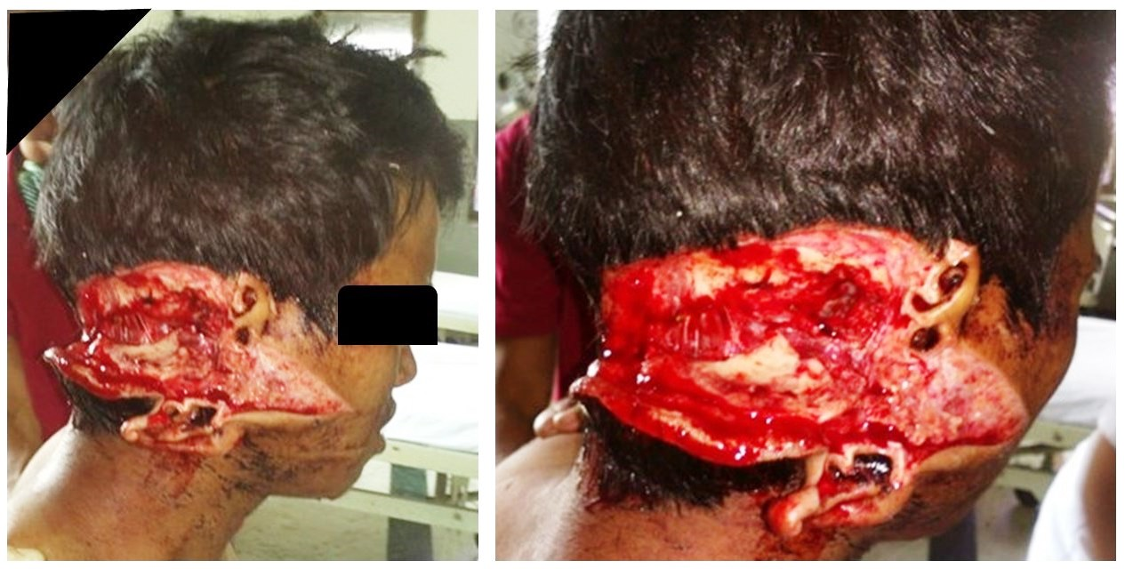

Figure 2: Penetrating metallic “fishing hook” embedded in the victim’s left cheek that was removed under local anesthesia, the wound was cleaned and sutured

